CS 324Compiler Design Lab

short line

Soumyabrata Bairagi

2019UGCS028R  
27th August, 2021

# Experiment 1

## Write a Lex program to detect whether an input string contains alphabets or digits.

### Source Code:

| %{  // Macros for C program %} digit [0-9] letters [a-zA-Z] %% {digit}+ {printf ("digit(s)");}; {letters}+ {printf ("letter(s)");}; .* {printf ("other characters");}; %% int main() {  yylex(); } int yywrap(void) {  return 0; } |
| --- |

### 

### Compiling and running the above lex code:

# 

# Experiment 2

## Write a Lex program to check whether the input string contains only alphabets or not.

### Source Code:

| %{  // Macros for C program %} letter [A-Za-z] %% {letter}+ {printf ("Letters\n");}; .* {printf ("Characters other than letters\n");}; %% int main() {  yylex();  } int yywrap(void) {  return 0; } |
| --- |

### Compiling and running the above lex code:

## 

# Experiment 3

## Write a Lex program to check whether the input contains only letters or only digits or both.

### Source Code:

| %{  // Macros for C program %} digit [0-9] letters [a-zA-Z] %% {digit}+ {printf ("digit(s)\n");}; {letters}+ {printf ("letter(s)\n");}; {digit}+{letters}+ {printf ("letter(s) and digit(s) both\n");}; .* {printf ("other characters");}; %% int main() {  yylex(); } int yywrap(void) {  return 0; } |
| --- |

### Compiling and running the above lex code:

# Experiment 4

## Write a Lex program to check whether the input string contains lower-case or upper-case letters.

### Source Code:

| %{  // Macros for C program %}  lower [a-z] upper [A-Z] both [a-zA-Z]  %% {lower}+ {printf("lowercase\n");}; {upper}+ {printf("uppercase\n");}; {both}+ {printf("Both\n");}; .* {printf("Other characters\n");}; %%  int main() {  yylex();  return 0; }  int yywrap() {  return 0; } |
| --- |

### Compiling and running the above lex code:

# 

# 

# Experiment 5

## Write a Lex program to check whether the input is a digit or not.

### Source Code:

| %{  // Macros for C program %} digit [0-9] %% {digit} {printf ("digit");}; .* {printf ("Not digit");}; %% int main() {  yylex(); } int yywrap(void) {  return 0; } |
| --- |

### Compiling and running the above lex code:

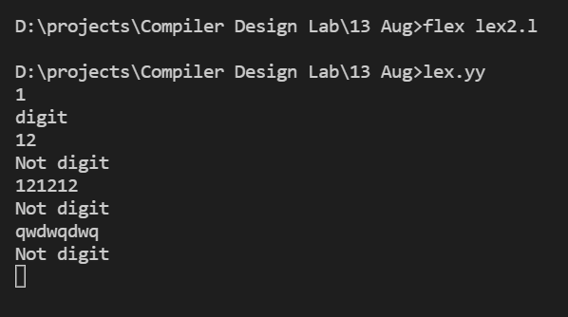

# Experiment 6

## Write a Lex program to detect whether a string contains consonants or vowels.

### Source Code:

| %{  // Macros for C program %} vowel [aeiouAEIOU] cons [b-df-hj-np-tv-zB-DF-HJ-NP-TV-Z] both [a-zA-Z] %% {vowel}+ {printf ("Contains only vowels");}; {cons}+ {printf ("Contains only consonants");}; {both}+ {printf ("Contains both vowels & consonants");}; .* {printf ("Contains other characters");}; %% int main() {  yylex(); } int yywrap(void) {  return 0; } |
| --- |

### Compiling and running the above lex code:

# Experiment 7

## Write a Lex program to count the number of characters in an input string.

### Source Code:

| %{  // Macros for C program  #include <stdio.h>  int ch = 0; %} %% . {ch++;}; \n {printf("No. of Characters: %d\n\n", ch); ch = 0;}; %% int main() {  yylex(); } int yywrap(void) {  return 0; } |
| --- |

### Compiling and running the above lex code:

# Experiment 8

## Write a lex program to count number of vowels and consonants in the input string.

### Source Code:

| %{  // Macros for C program  #include <stdio.h>  int nv = 0, nc = 0; %} vowel [aeiouAEIOU] cons [b-df-hj-np-tv-zB-DF-HJ-NP-TV-Z] %% {vowel} {nv++;}; {cons} {nc++;}; \n {return 0;}; . %% int main() {  yylex();  printf("No. of Vowels: %d\nNo. of Consonants: %d\n\n", nv, nc);  } int yywrap(void) {  return 0; } |
| --- |

### Compiling and running the above lex code:

# Experiment 9

## Write a Lex program to count number of characters, white spaces, tabs in a string.

### Source Code:

| %{  // Macros for C program  #include <stdio.h>  int nc = 0, nt = 0, nw = 0; %} wspace [ ] %% \t {nt++;}; {wspace} {nw++;}; . {nc++;}; \n {return 0;}; %% int main() {  yylex();  printf("No. of Characters: %d\nNo. of Whitespaces: %d\nNo. of Tabs: %d\n\n", nc, nw, nt);  } int yywrap(void) {  return 0; } |
| --- |

### Compiling and running the above lex code: